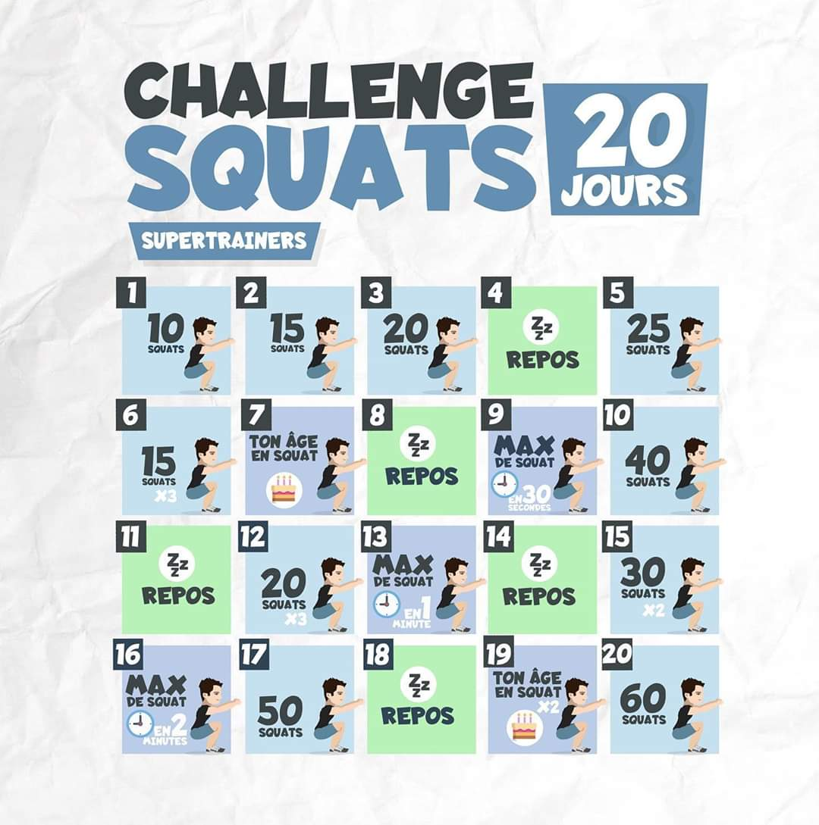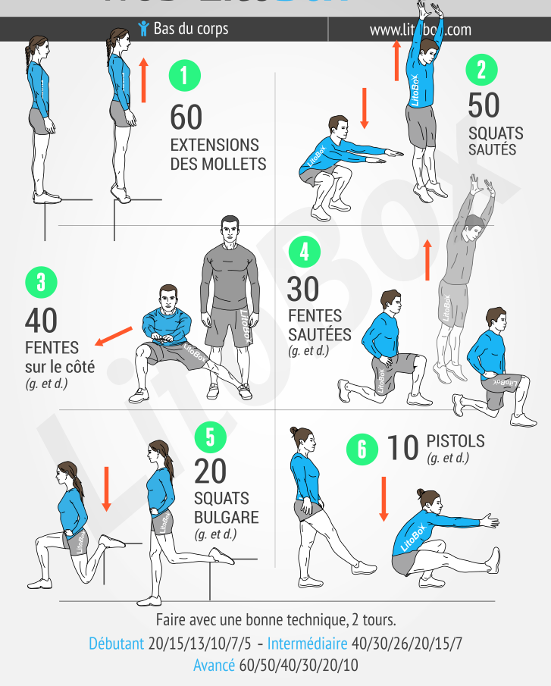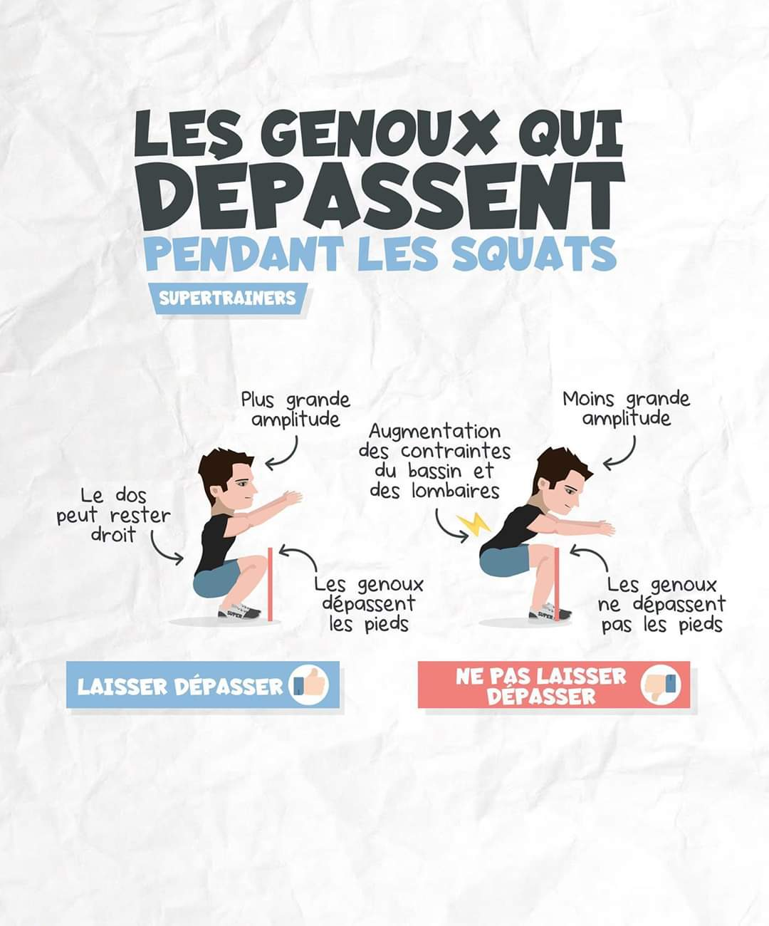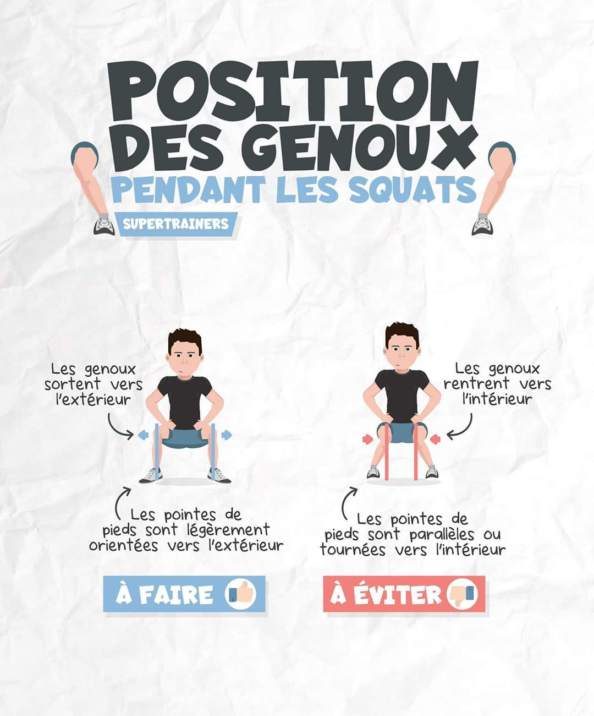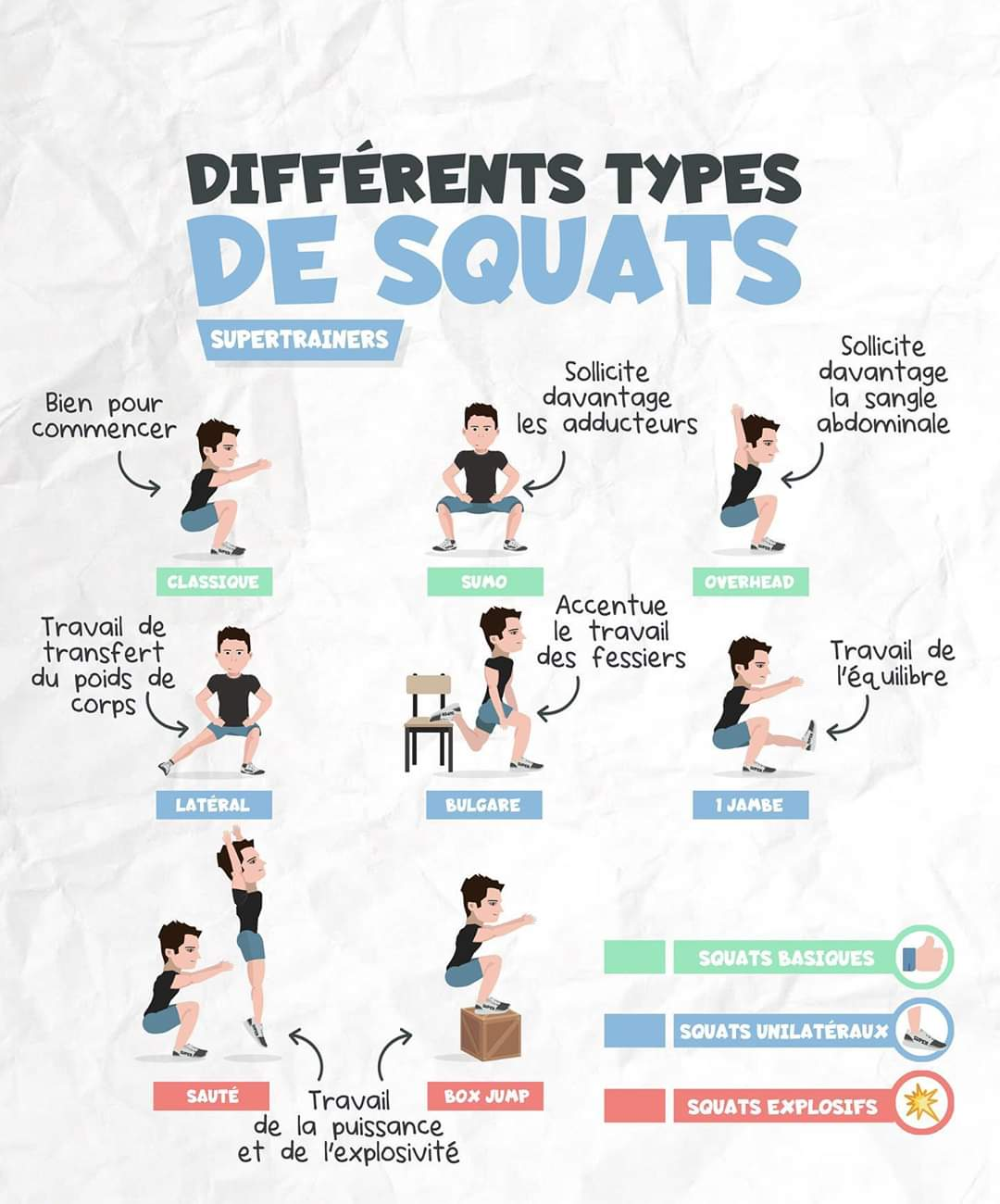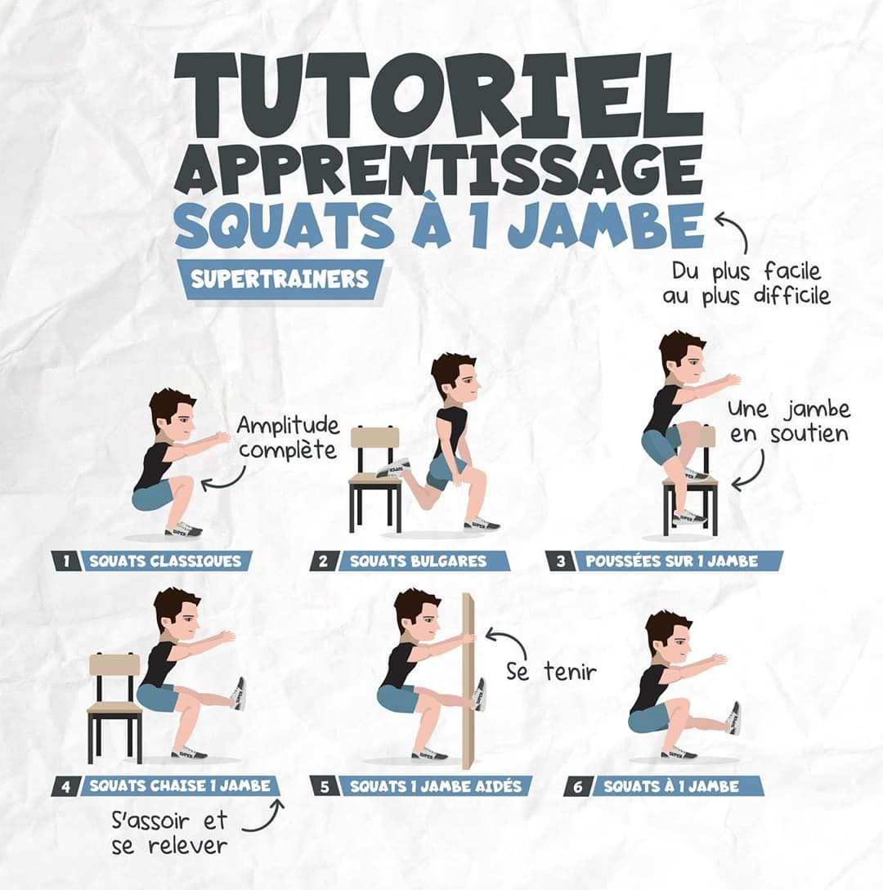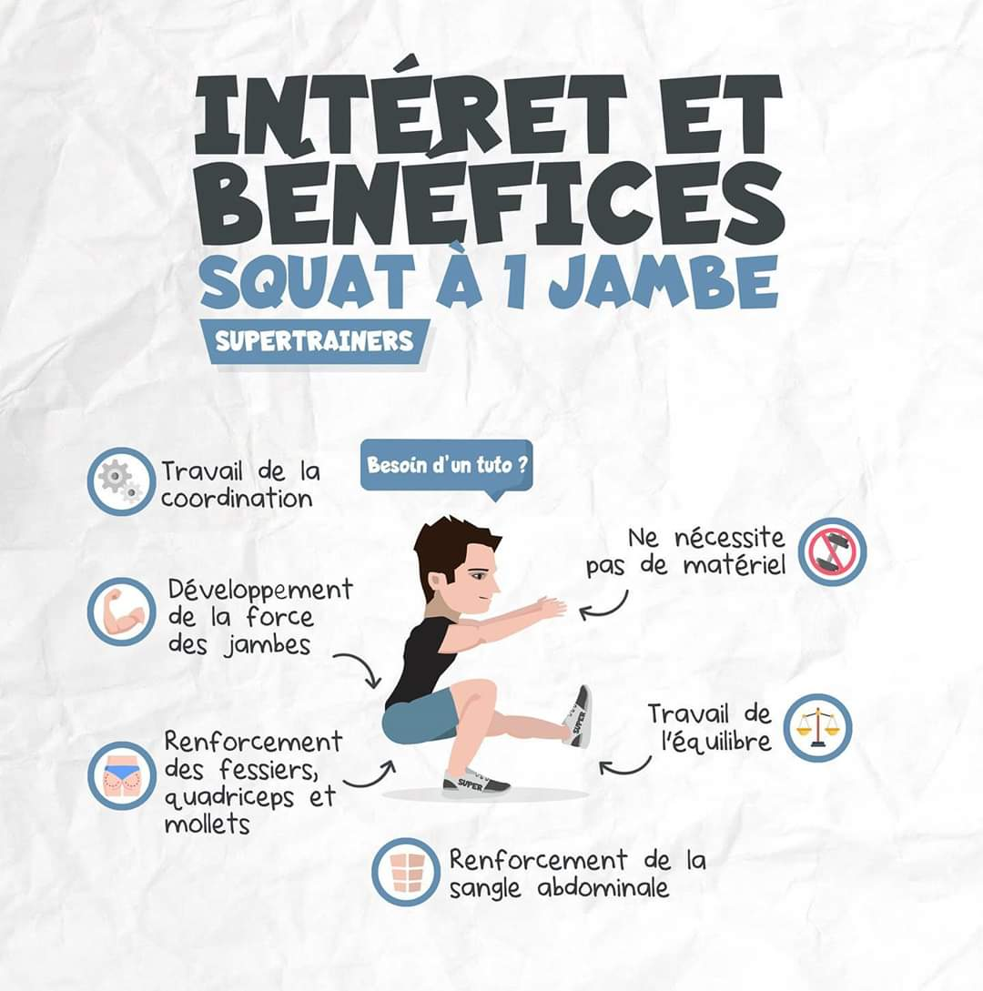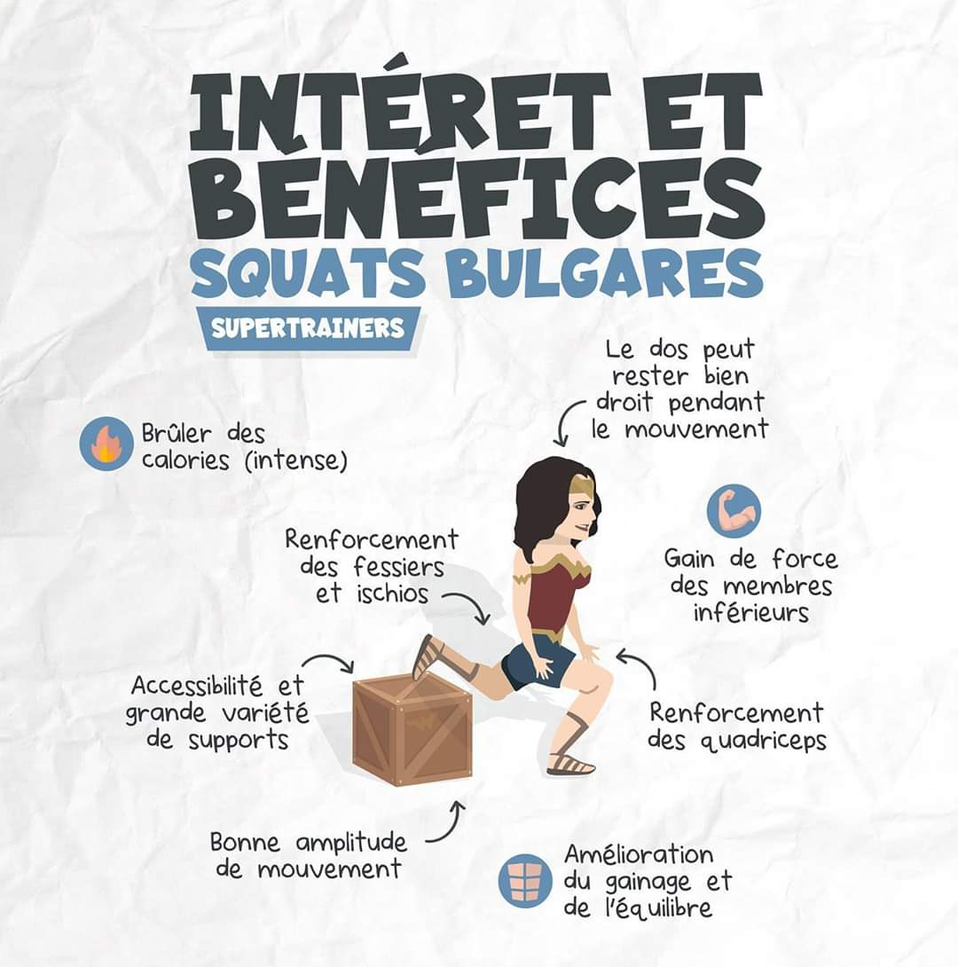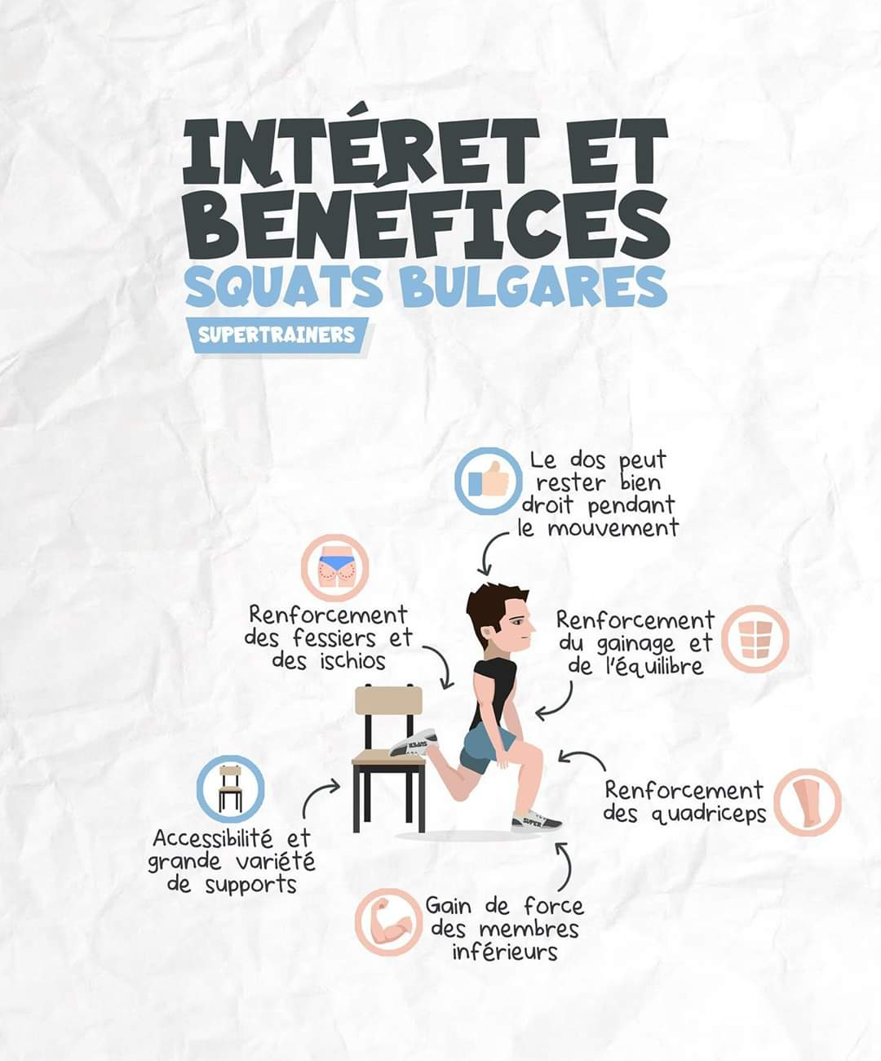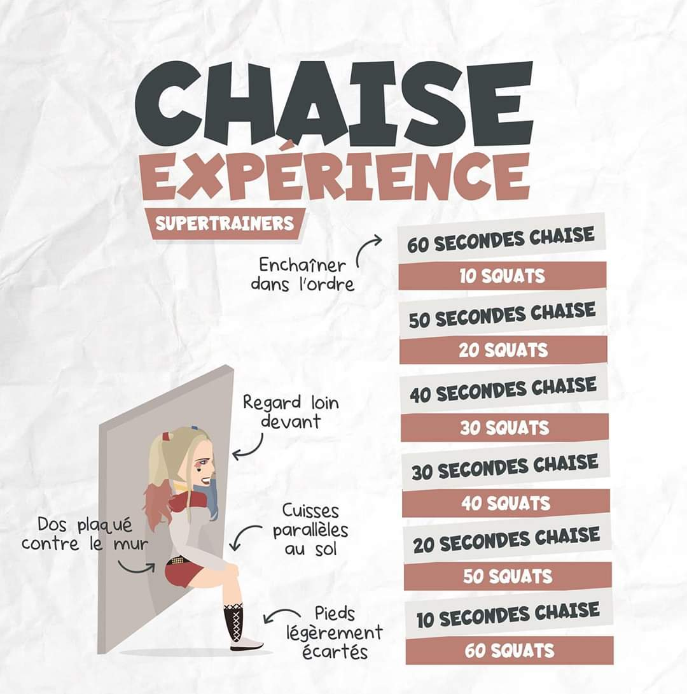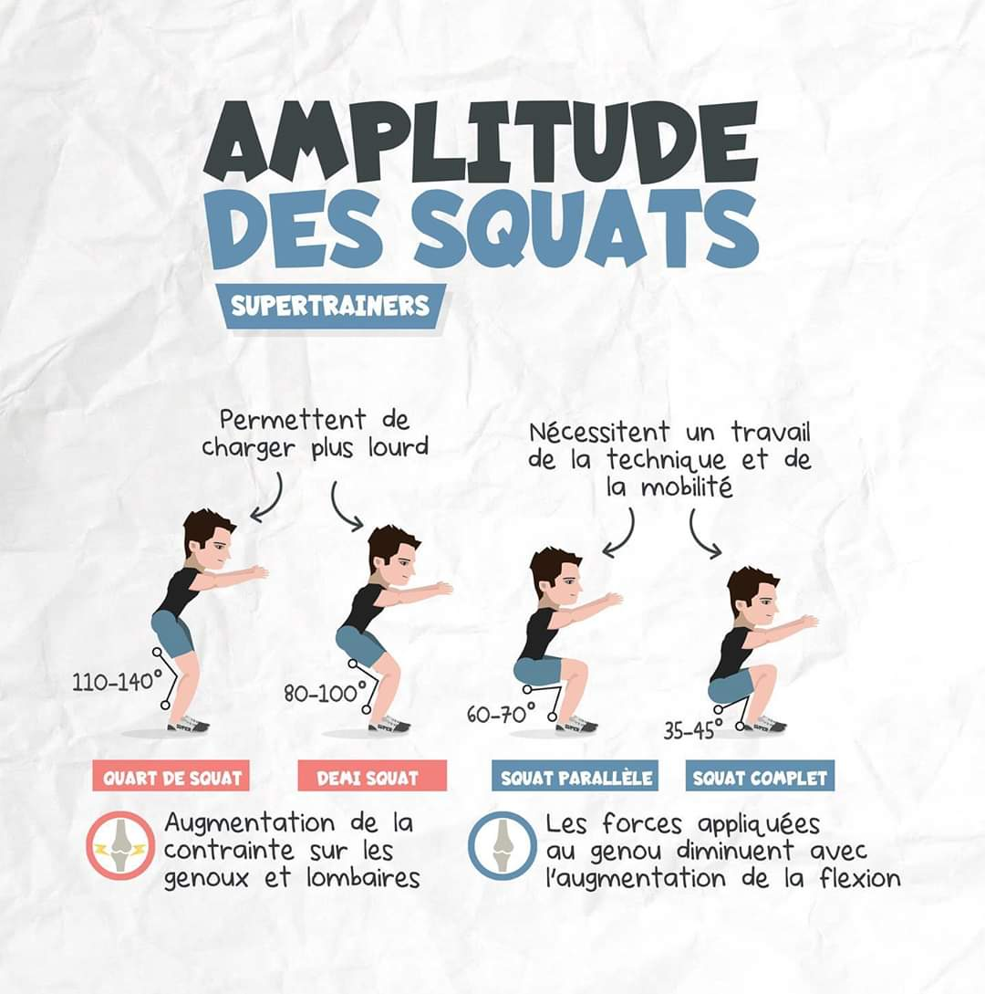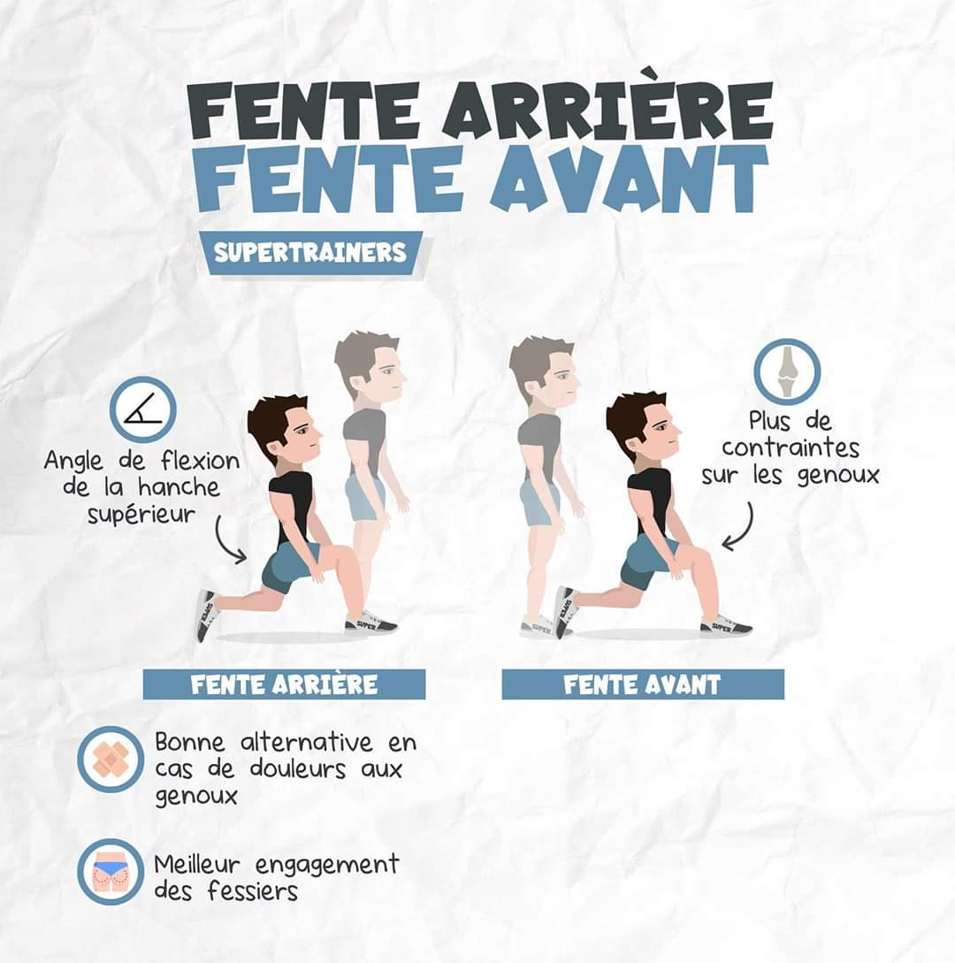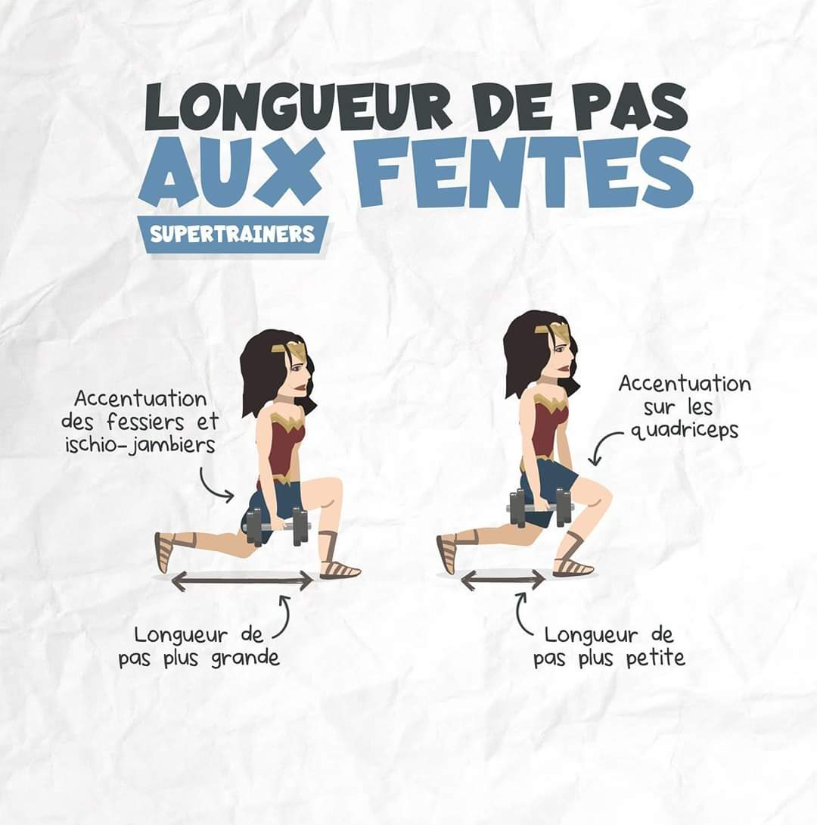

***Challenge 30 jours / 30 Squats***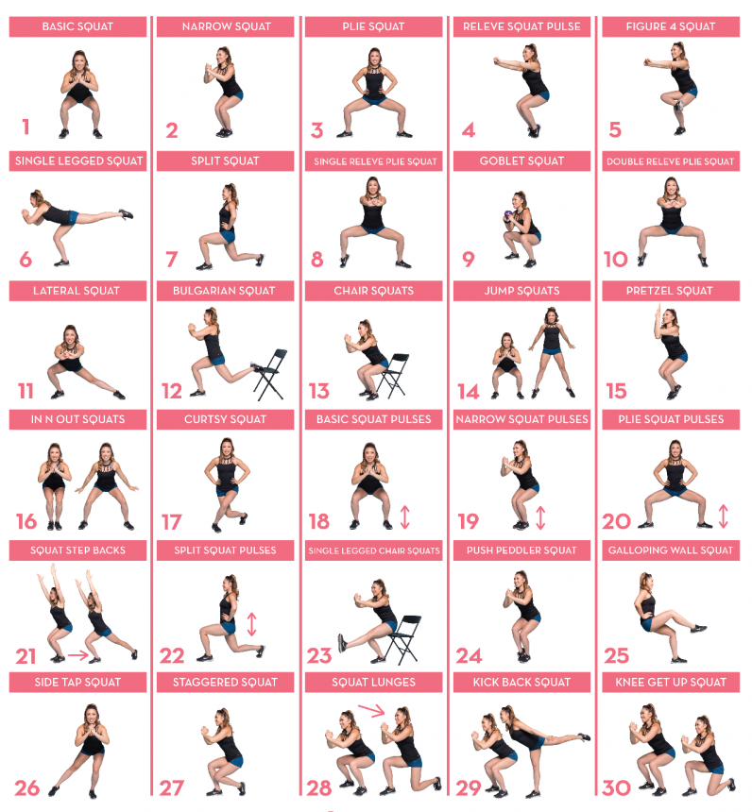

|  |  |
| --- | --- |
| 1. Basic squat 2. Narrow squat 3. Plie squat 4. Releve squat pulse 5. Figure 4 squat 6. Single legged squat 7. Split Squat 8. Single releve plie squat 9. Goblet squat 10. Double releve plie squat 11. Lateral squat 12. Bulgarian Squat 13. Chair squats 14. Jump squats  15. Pretzel squat | 16. In n Out Squats 17. Curtsy Squat 18. Basic squat pulses 19. Narrow squat pulses 20. Plie squat pulses 21. Squat Step Backs 22. Split Squat Pulses 23. Single Legged Chair Squats 24. Push Peddler Squat 25. Galloping Wall Squat 26. Side Tap Squat 27. Staggered Squat 28. Squat Lunges 29. Kick back squat 30. Knee Get Up Squat |